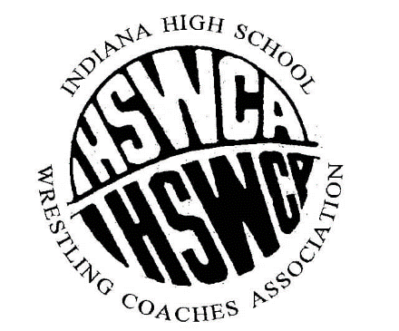
President – Danny Struck- Jeffersonville V.Pres. – Jason Cook- Hobart Sec– Sam Riesen – East Noble

Old Business:
- Meeting Minutes- minutes from Fall Clinic (Sam Riesen)
  - Sam Riesen read the minutes from the fall clinic
- Financial Report-(JD Minch)
  - A little over $25,000
  - Middle School State made a large amount
  - Discussion of uses of the $
- Membership Report-(JD)
  - 296 current member similar to years past
- IHSWCA/IHSAA/IIAAA Meetings – (Danny Struck)
New Business:
- Girls Wrestling Emerging Sports Status
  - Prior to emerging sports status, 168 schools needed wrestling
  - After last years presentation the IHSAA passed the concept of emerging sports
  - Will be emerging until we reach 160+ schools
  - Emerging means the IHSAA likes the sport, we are backed by the IHSAA, the sport is not officially recognized though
  - Q and A
    - Will finals be IHSWCA or IHSAA?
      - Will have a new association under the IHSWCA umbrella, currently the tournament will be the same dates and locations as current IHSGW event
    - How many girls constitutes a team?
      - 1
    - Dates and Times
      - The IHSAA will have final say on what season the sanctioned sport will fall under.
    - If it hits 50% will girls wrestling automatically become an IHSAA sport
      - No, it would mean girls wrestling can have a vote
    - Are there issues with Title IX?
      - No
    - Will girls be able to wrestle boys next season?
      - This question will not be answered until the IHSAA Meetings this summer
- IHSWCA Team State Invitational (Greg Ratliff)
  - Locations still being finalized
  - Discussion of positives and negatives of multiple sites
  - Will continue on the same weekend
- Middle School State (Jake O’neill)
  - Dates and locations to be finalized
  - Goal for final details in November
- Recognition of the 2021-22 Regional Coaches of the Year (Sam Riesen)
  - Regional Coaches of the year were recognized, and given a plaque
- Officer nomination process explained (Danny)
  - Process of VP becoming president were explained
  - Nominations will be this fall
- HOF Update (Danny)
  - Meeting for voting for 2021-22 class was after the spring clinic
- New Weight Classes 2023-2024 (Danny)
  - New weights (NFHS) will be adopted for the 2023-2024 season
- New rules for 2022-2023 (Danny)
  - New NFHS rules were recently adopted
- Sectional Realignment Update (Danny)
  - Nothing coming this upcoming season
- Good of the cause
  - Jim Grunwald discussed his book “Not all Roads Lead to Gold”
  - Dave Cloud (NWCA)
    - Brandon Lorek National Coach of the Year
    - Convention July 29-31st Jacksonville
    - Henryville High School wants to start a program, needing a coach
    - Academic Challenge
      - Dekalb
      - Roncolli
      - Carmel
      - 3.25 or higher would be Honorable Mention
    - Call for mentorship program for young coaches

